The university of Azad Jammu and Kashmir Muzaffarabad

Student Name: Qurat Ul Ain Fatima
Roll No: 2024-SE-05
Course Title: Database Systems
Course Code: CS-2204
Lab Instructor: Awais Rathore
Department: Software Engineering
Lab#05

Database Creation:
In the beginning, a new database was created for the project.
This was done to provide a separate workspace where all related operations could be performed in an organized manner without affecting any other data.

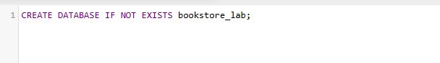
Table Creation:
A new table was created inside the database to store structured information.
The table was designed in such a way that it could hold multiple records and support different types of data required for the project.
This step established the main structure for storing all information used in the system.

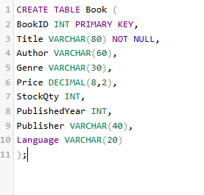
Data Insertion:
After creating the table, multiple records were added to it.
These records represented different entries used for testing and analysis purposes.
The data included a variety of cases so that different types of SQL operations could be practiced effectively, including:
complete records
missing information cases
different categories and values
This helped in making the dataset realistic for querying.
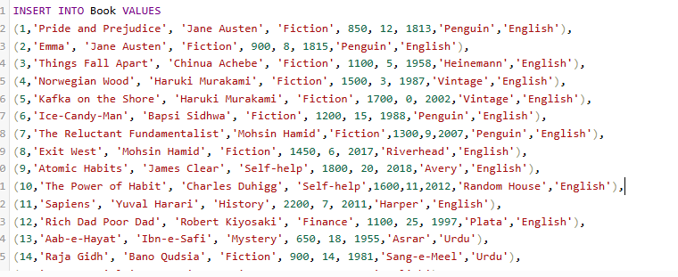
Query Execution :
Once the setup was complete, different SQL queries were performed on the table.
These queries were used to:
filter specific results based on conditions
search for patterns in text data
identify missing or unknown values
sort results in a meaningful order
limit output to required results
Each query focused on practicing a different SQL filtering technique.
Q1:
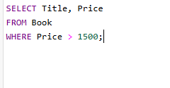
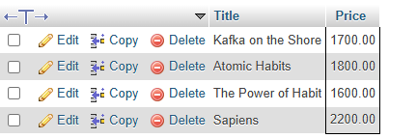
Q2:
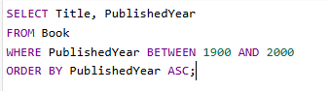
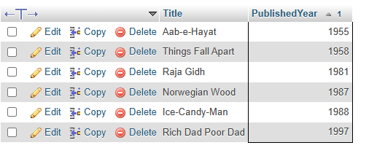
Q3:
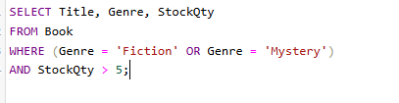
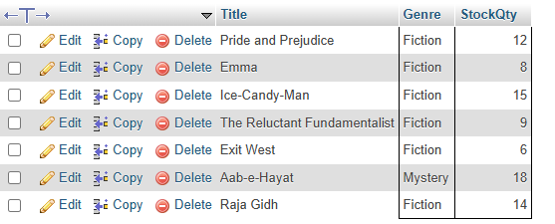
Q4:

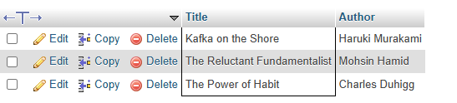
Q5:
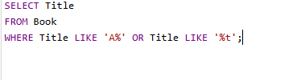
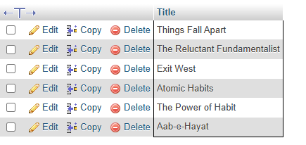
Q6:
